Microgrid MATLAB Simulation Documentation

# Initial Set Up

The files and folders in the following table are needed to run the simulation. They should all be in the same folder.

|  |  |
| --- | --- |
| File/Folder | Description |
| MG_LP_Test_vX_X.m | Main MATLAB script file, currently MG_LP_Test_v9_2.m |
| Import_A_b.m | Imports matrices for microgrid nodes from Excel file |
| Import_MG_State.m | If the option is set, imports the state of the microgrid at each timestep |
| Import2000_NPS.m | Imports solar irradiation data from CSV file for a random year |
| ImportLoads.m | Imports building load data from CSV files |
| ImportMission.m | Imports mission data for each load from Excel file |
| ImportTY_NPS.m | Imports solar irradiation data from CSV file for a typical year |
| MG_Failure_State.m | Sets the failure state of the microgrid when Random Failure option is chosen |
| MG1v2 Report.xlsx | Excel file for user input. |
| BldgData | Folder containing CSV files with building load data |
| SolarData | Folder containing CSV files with solar irradiation data |
|  |  |

# Setting up a simulation

## MG1v2 Report.xlsx Excel File

Within the Mission tab of the Excel file, “MG1v2 Report.xlsx”, the Load name, (e.g. EP1, EP2, etc.) average critical and normal load, and amount of critical mission is input by the user for the facilities. The name of each load must match the name used throughout the other inputs and options.

The Matrix tab of the Excel file is used to set the matrix *A* and vector *b* defining the load balance at each node is set for both utility grid connected mode and island mode and the variable names of each line within the network. The naming convention used is *source_end*, e.g. *B2_BT1* is the line from node B2 to BT1 (bus 2 to battery 1). Only the first two matrices and vectors for the two modes and variable names are imported into the MATLAB file. The other matrices below assisted in setting up the MATLAB code when failures occur but are not directly imported.

The MG_State tab of the Excel file is used to set the functional state of each line at each timestep of the simulation when “Import State” mode is selected for the simulation. The state is input by the user as either 0 for failed or 1 for functional for each line at each time step. Where a component is assumed to have failed, the state of the line to that component is set to failed in the simulation as equivalent.

## Main MATLAB Script File: MG_LP_Test_vX_X.m

Within the main MATLAB script file, user options for the simulation can also be set directly within the code as described in the following sections, started in the section labeled %% Set Model Options.

Set the number of simulations to use for the Monte Carlo simulation. Set this to 1 for a single simulation.

%Set Number of Iterations for Monte Carlo Simulation

MC = 100;

Set the name for the simulation scenario. This name is used within the output file data to help the user keep track of the intent of each simulation. The is set within the second string, e.g. 'Two week Islanded Operation. Total Loss of GEN1. Priority Sort.' As shown in the below example.

% Set Scenario Name for Settings Summary Output File

MGSettings = {'Scenario', 'Two week Islanded Operation. Total Loss of GEN1. Priority Sort.'};

The next sections set the user options for the year, grid mode, and random failure mode. These are set using prompts during code execution and do not need to be set within the code.

The remaining sections allow input for the microgrid design. This allows setting the photovoltaic (PV) array size and efficiency.

%PV Data

PV.Area = 3000; %area in m^2

PV.eff = 0.18; %PV efficiency

The next section sets the generator capacity, fuel storage, efficiency, refueling time, probability of successful refueling, and whether to assume the generators are fueled at the same time or independently.

%Generator Data

Gens(1).Capacity = 300; %kW

Gens(1).Storage = 5300/2; %Gal

Gens(1).Efficiency = 1/13; %(GPH/kW)

Gens(1).Refuel = 7*24; % # of hours between refueling

Gens(1).PrRefuel = 0.95; % Pr of Refueling each time

Gens(1).RefuelTogether = true; %Set if refueling is together or independent

Gens(2) = Gens(1); % Identical Generators

The next section sets the design data for the energy storage system. The design data used is the storage capacity, maximum output, and efficiency. Efficiency is the one-way efficiency and is assumed to be the same for both discharging and charging.

%Battery Storage Capacity in kW*hr, Output in kW

BT1.Capacity = 3000;

% BT1.Output = BT1.Capacity*0.20;

% Test with battery output override to test impact

BT1.Output = 300;

BT1.Efficiency = sqrt(0.95); % One way efficiency.

If random failure mode is intended to be used, the options what fails and for how long are set within the MATLAB script file “MG_Failure_State.m”. The failed component of line is set in the following section of code. Multiple lines can be set to fail at once, such as the example below where both ‘B1_B2’ and ‘B2_B1’ are set to fail.

% Set the Failed Line

failure.line = {'B1_B2' 'B2_B1'};

The failure time is then set in the following section. This can be set using one of the probability functions within MATLAB. In the below example, it is set for 7 days.

% Set the number of hours of failure

failure.time = 7*24;

# Running the Simulation Code

## Dialog selections

Running the main MATLAB script file, “MG_LP_Test_vX_X.m”, simulates the microgrid. Three options are set via dialog boxes when the script is run. The first option is the year of the solar data, as shown in Figure 1. A year between 2000 to 2009 can be selected, and actual solar data from that year will be used for the simulation. A typical year (TY) can also be used for the simulation, which assumes a typical meteorological year. Random will choose a random year from 2000 to 2009 for each iteration of the simulation.

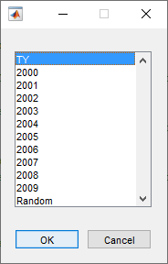

Figure 1 - Solar Data Year Dialog Box

The second dialog box, shown in Figure 2, is used to choose the microgrid state during the simulation. Grid Connected simulates the grid for a two-week duration while the utility grid connection is available. Islanded mode does the same for when the microgrid is operated in island mode without availability of utility power. Import State imports the state of the microgrid at each time step from the MG_State sheet of the MG1v2 Report.xlsx and the simulation duration for each iteration is set by the number of rows of data.

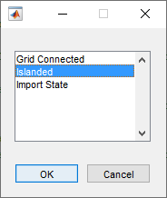

Figure 2 - Mode Selection Dialog Box

The last dialog box sets whether to apply a random failure during each iteration of the simulation. If Yes is selected than the selected component(s) fail at a random time during the simulation as defined within the “MG_Failure_State.m” script file.

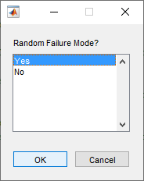

Figure 3 – Random Failure Mode Dialog Box

## Simulation Results

The simulation then runs at this time. During the simulation, the iteration number and year is output to the MATLAB console. At the conclusion, the data is exported to files. If only one iteration was performed, then the following files with the results of the simulation are exported:

* MG_LP_Test_Output.csv
* MG_Sim_Output_Table.csv

Each file contains the power flows within the microgrid, battery charge level and power flow, and generator fuel level at each time step. This can be used to perform detailed analysis on causes of load shedding or analysis of a specific scenario of interest. The second CSV files is a table version of the first. The data exported to this file can also be viewed within the main Excel file, “MG1v2 Report.xlsx”, in the Output tab. Refreshing the query will update the Excel table and charts with the latest csv file data (Note: Excel queries use a static file reference, and must be updated to point to the correct file for each computer). Additionally, for a single simulation, graphs of the data will also be produced by MATLAB at the end of the simulation. An example of one of these graphs is shown in Figure 4.

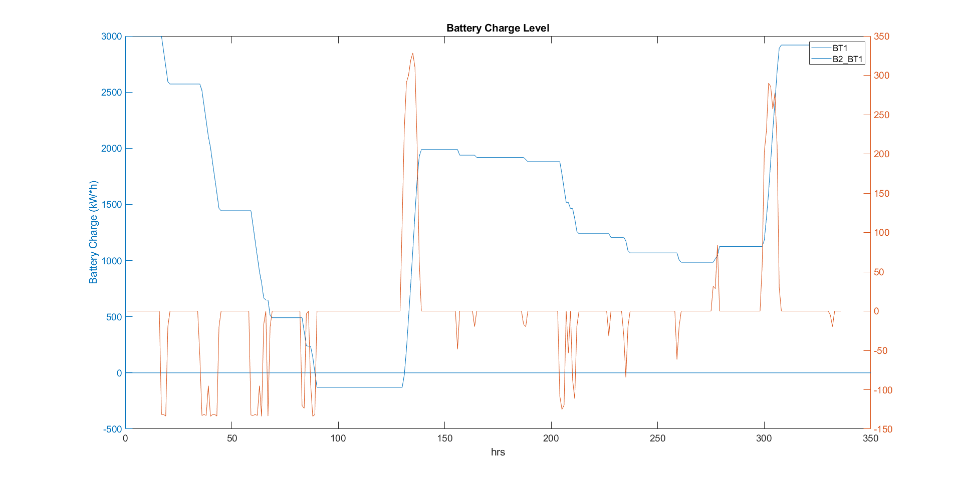

Figure 4 – Sample Graph showing Battery Charge State and Power Flow

If more than one iteration was used, a Monte Carlo simulation is assumed, and the summary of the results is written to the files as described in the below table.

|  |  |
| --- | --- |
| File Name | Description |
| MG_Sim_MC_Settings.csv | The settings for the microgrid simulation and summary of the microgrid design. |
| MG_Sim_MC_Results.csv | Summary of results from each iteration. |
| MG_Sim_MC_Summary.csv | Overall summary statistic of the results from all simulations in terms of average, max, min, and standard deviation. |
| MG_Sim_MC_MG_State.csv | State of the microgrid used for the input into each iteration. |

These files include the overall summary of the results in terms of mission impact, load shedding at each load, number of hours the battery was exhausted, and number of hours the generator fuel tanks were empty.

# Simulation Code Documentation

The main MATLAB code file for the simulation is MG_LP_Test_vxxx.m, where xxx denotes the version. The latest version as of the writing of this documentation is “MG_LP_Test_v9_2.m”. the MATLAB script code is broken into sections as follows:

1. Clear workspace
2. Set Model Options
3. Import A and b Matrix Values
4. Import Solar Data
5. Import Load Data and Mission Importance
6. Setup Results Variables
7. Setup the microgrid state table.
8. Setup the microgrid initial conditions
9. Run Linear Solver to find flows
10. Calculate Results of Each Iteration
11. Output to files
12. Write Summary to Console
13. Plot Results

## Clear Workspace

The section of code clears the workspace and all variables to reset the simulation.

## Set Model Options

This section sets the options for the design of the microgrid and simulation options.

## Import A and b Matrix Values

The section imports the A and b matrices from the Excel file “MG1v2 Report.xlsx”. The importation is performed by called the “Import_A_b” MATLAB script.

## Import Solar Data

This section imports the solar data in form of a MATLAB table from the CSV files located in the SolarData subfolder. The year is set within the Model Options section of the script file. For a typical meteorological year, the script “ImportTY_NPS” is called. Otherwise the “Import2000_NPS” script is called.

## Import Load Data and Mission Importance

This section imports the loads from the CSV files located within the BldgData subfolder. The importation is performed by called the “ImportLoads” script. The mission importance is also imported for each load within the microgrid by calling the “ImportMission” script. The mission importance data is imported from the Mission sheet of the Excel file “MG1v2 Report.xlsx”

## Setup Results Variables

This section creates the variables that are used to store the results for each iteration. The results are stored in a MATLAB table, with each variable stored in a column and each row consisting of the results for that iteration.

## Setup the microgrid state table.

This section creates the table that stores the initial functional state of each line/component in the simulation. If “Import State” option was selected, then the table is created by calling the script file “Import_MG_State”. This imports the user entered data from the MG_State sheet of the Excel file “MG1v2 Report.xlsx”. Otherwise, the functional state is set to true at each timestep, and the utility grid connection is set to false if “Island Mode” was selected in the simulation model options.

## Setup the microgrid initial conditions

This section sets the initial conditions for each of the components within the microgrid. The generator fuel levels and battery state are both assumed to be full at the start of each iteration of the simulation. This section also set the initial timing for the next refueling of the generators and resets the variables which store load shedding during each iteration. The time of year is set to a random time for each iteration. Lastly, if the option for a random year was selected, a random year is set at the start of each iteration and the solar data for that year imported.

## Run Linear Solver to find flows

This section runs the linear solver to find the power flows within the microgrid at each time step. This section modifies the A matrix and b vector based on the functional state of the lines/components within the microgrid. A and b are also modified to meet constraints for generator output and energy storage output, applying the control logic as shown in Figure 5. Load is shed as necessary to meet these constraints.

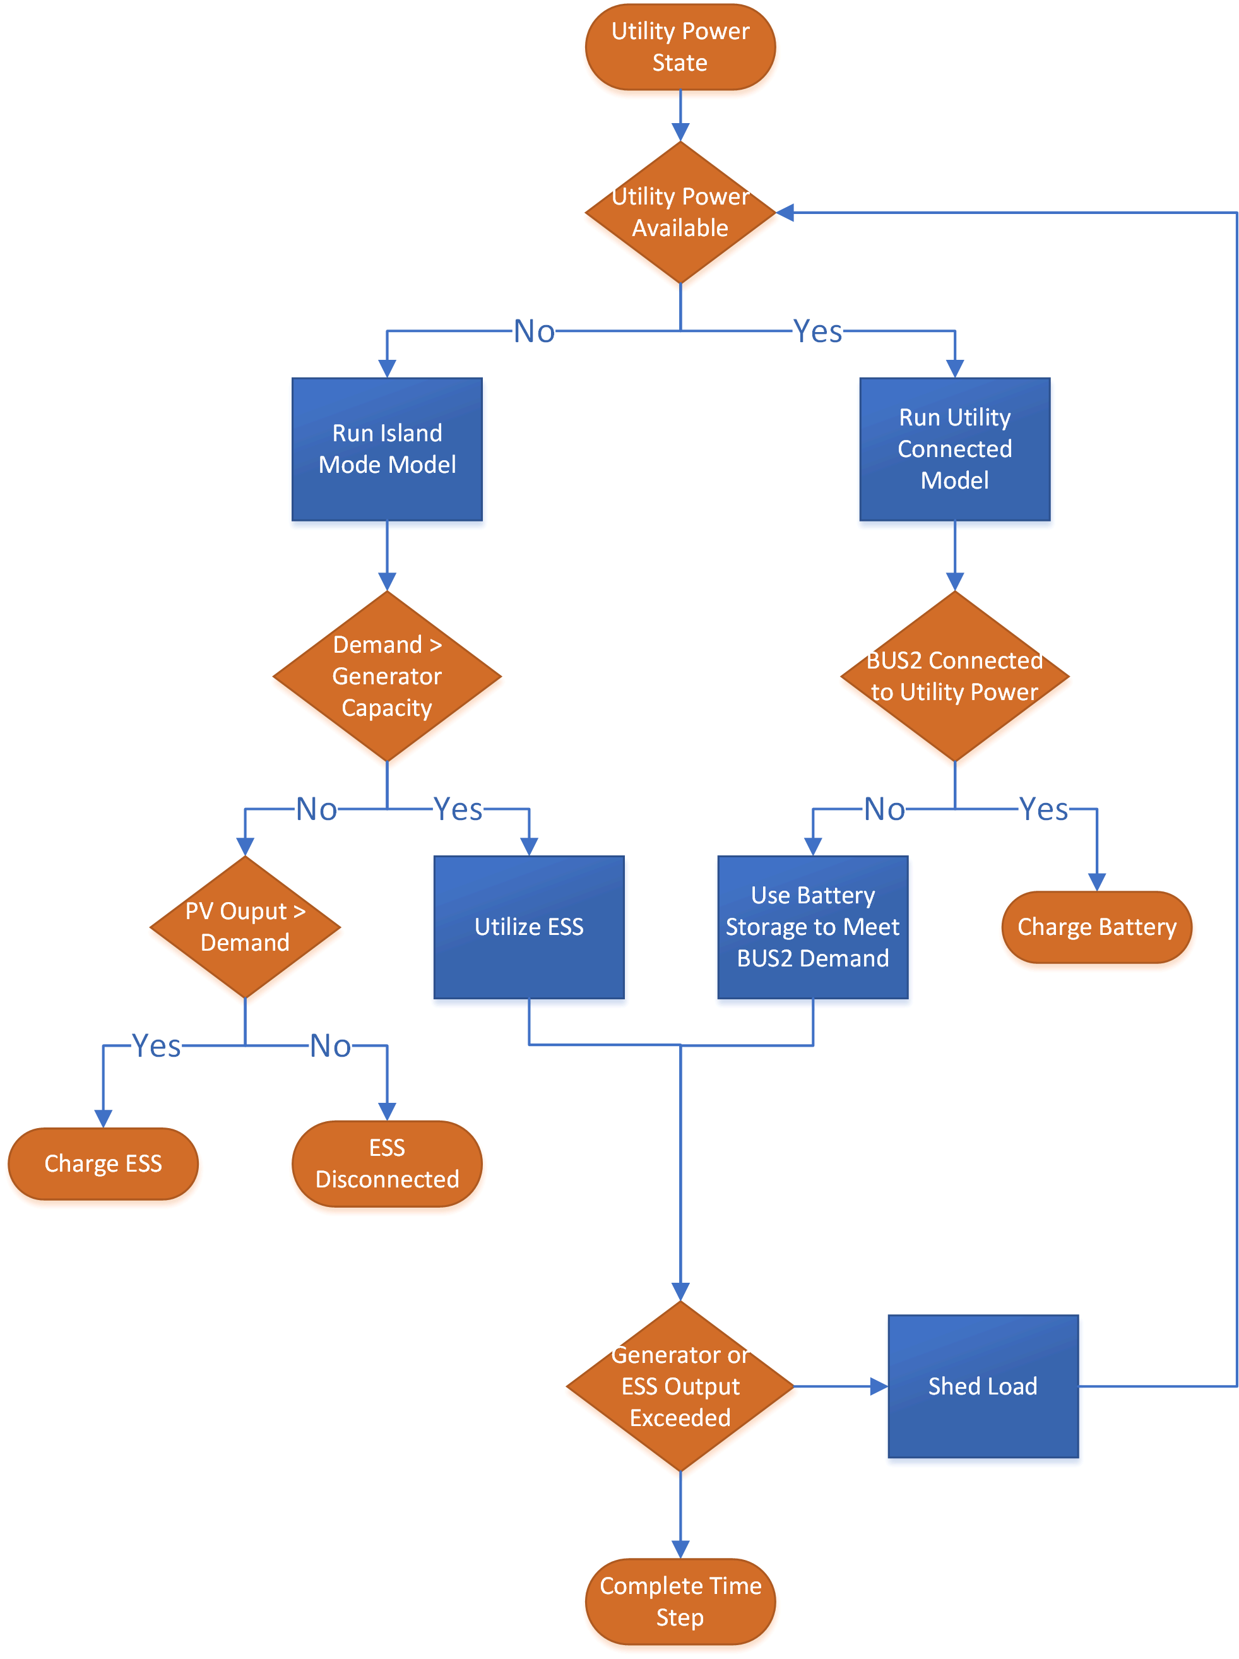

Figure 5 – Microgrid Control Logic

## Calculate Results of Each Iteration

After the end of each iteration, this section calculates the overall summary results for that iteration. The results for each iteration are stored in a row within a MATLAB table. The total mission impact, number of hours the battery is exhausted, number of hours each generator is out of fuel, number of hours each facility has load shed, and total load shed at each facility is calculated.

## Output to files

This section outputs the results to CSV files. If a single iteration was simulated, detailed hourly results are output. For multiple iterations for Monte Carlo simulation, the summary results for each iteration and total summary statistics for all iterations is output to CSV files.

## Write Summary to Console

If a single iteration was simulated, this writes summary statistics to the MATLAB console. A summary of the mean and max loads for each facility and the PV output is output. This section also writes the total number of hours that load shedding took place during the simulation.

## Plot Results

If a single iteration was simulated, this produces three graphs showing detailed data. The first graph is the power flow within the microgrid. The second graph is of the power flow into and out of the storage battery and the state of charge of the battery. The third graph displays the generator fuel level for each generator throughout the simulation.